**SAP HANA Tables**

**Authored By**

Divya Jayaprakash (dxj160830)

MIS 6345.0W1 - High Performance Analytics - Spring 2017

Professor. Mr.Kashif Saeed

SAP HANA Tables:

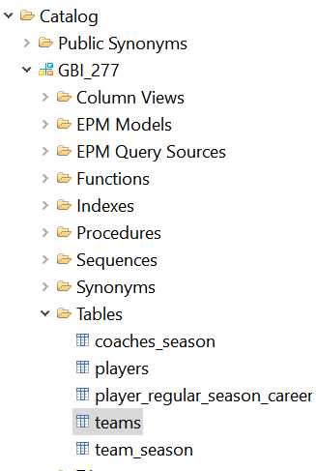

**Table:Players**

**Table Definition: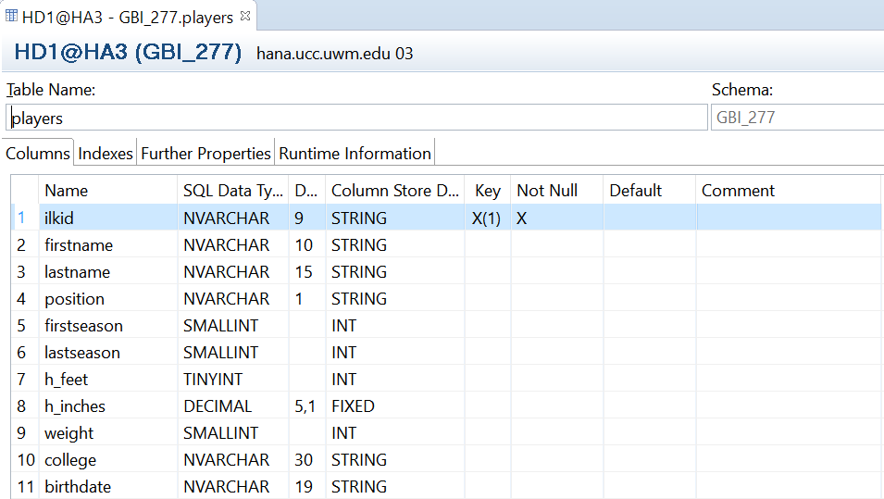Imported Table Loaded With Data:**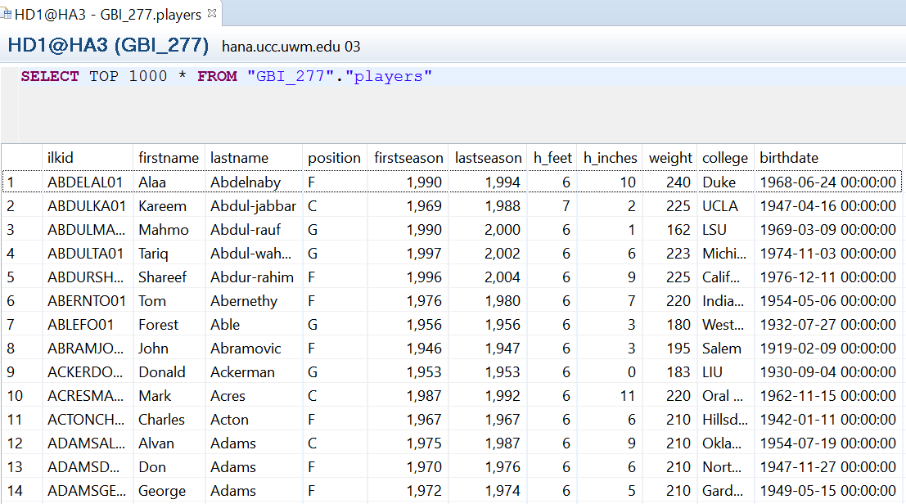

**Table:Player_Regular_Season_Career**

**Table Definition:**

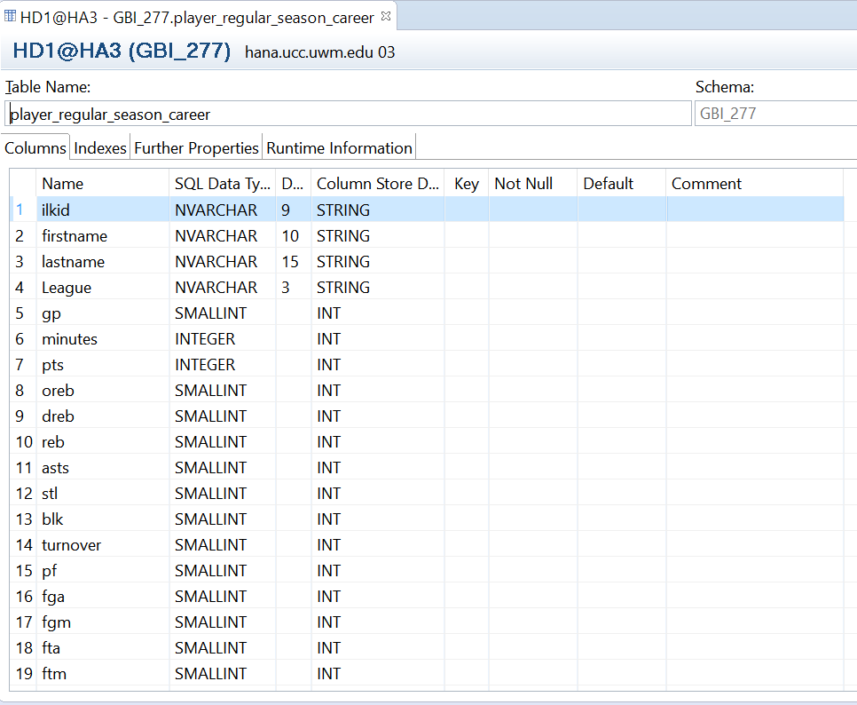

**Imported Table Loaded With Data:**

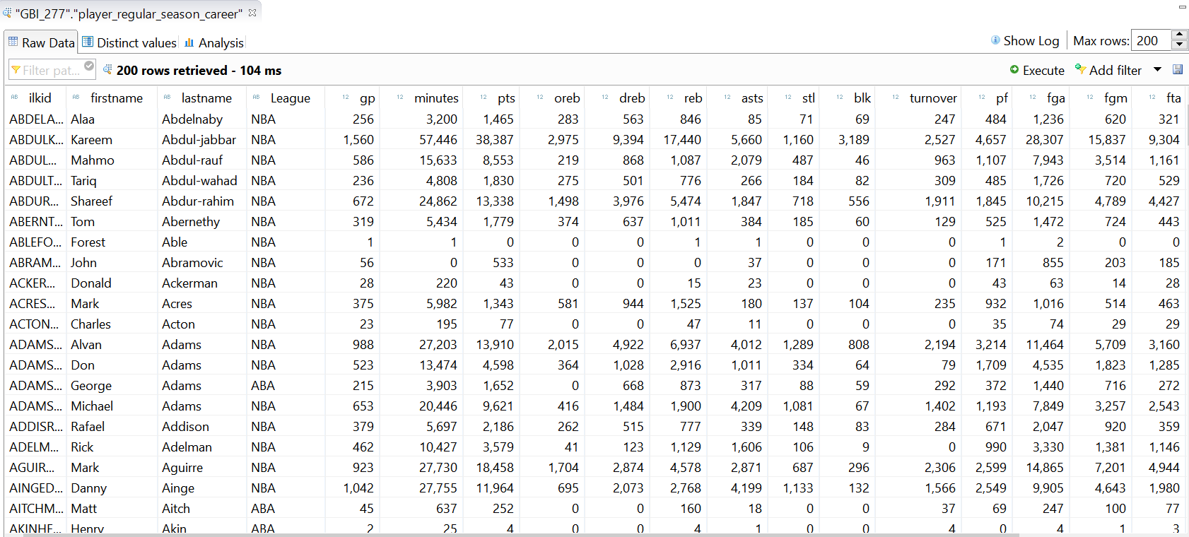

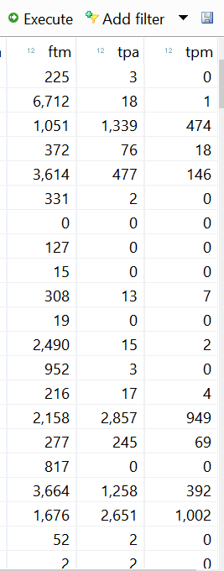

**Table:Teams**

**Table Definition:**

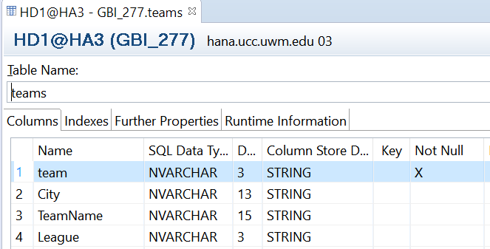

**Imported Table Loaded With Data:**

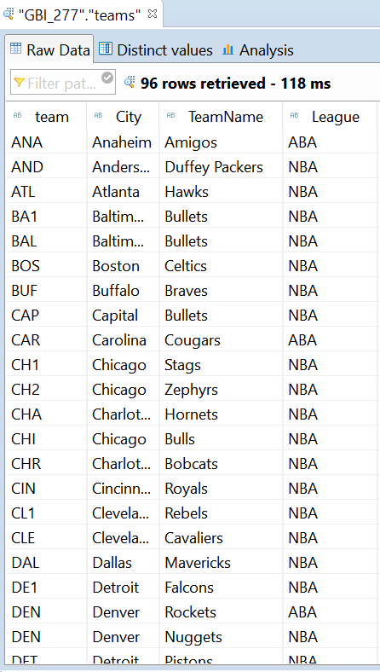

**Table:Team_Season**

**Table Definition:**

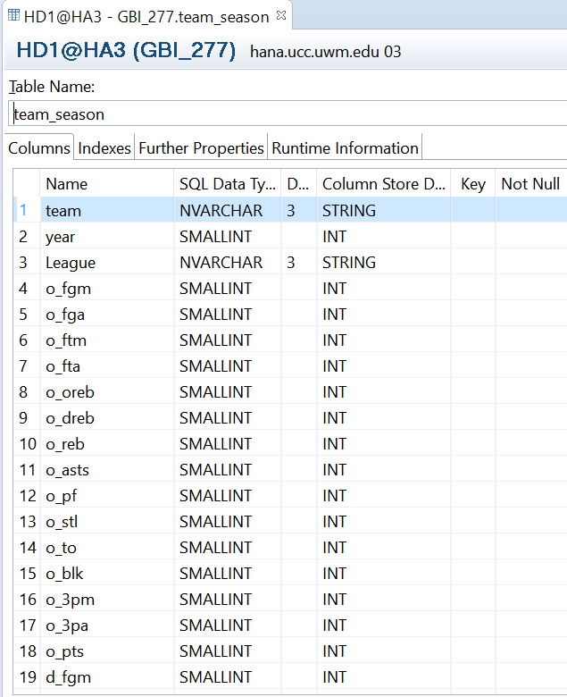

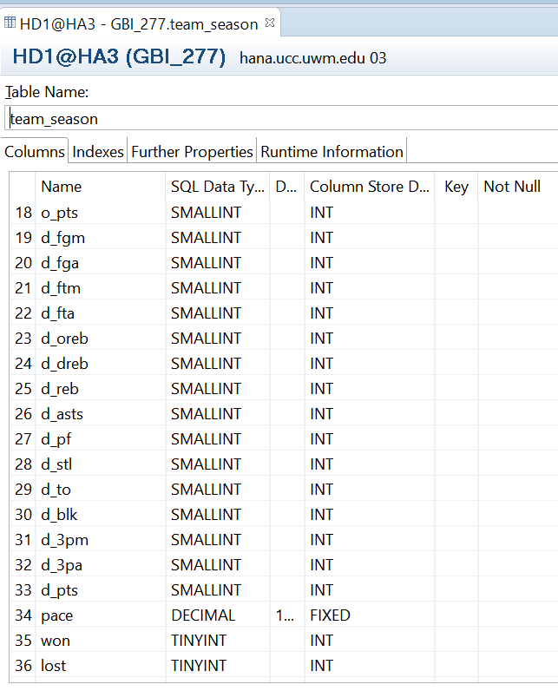

**Imported Table Loaded With Data:**

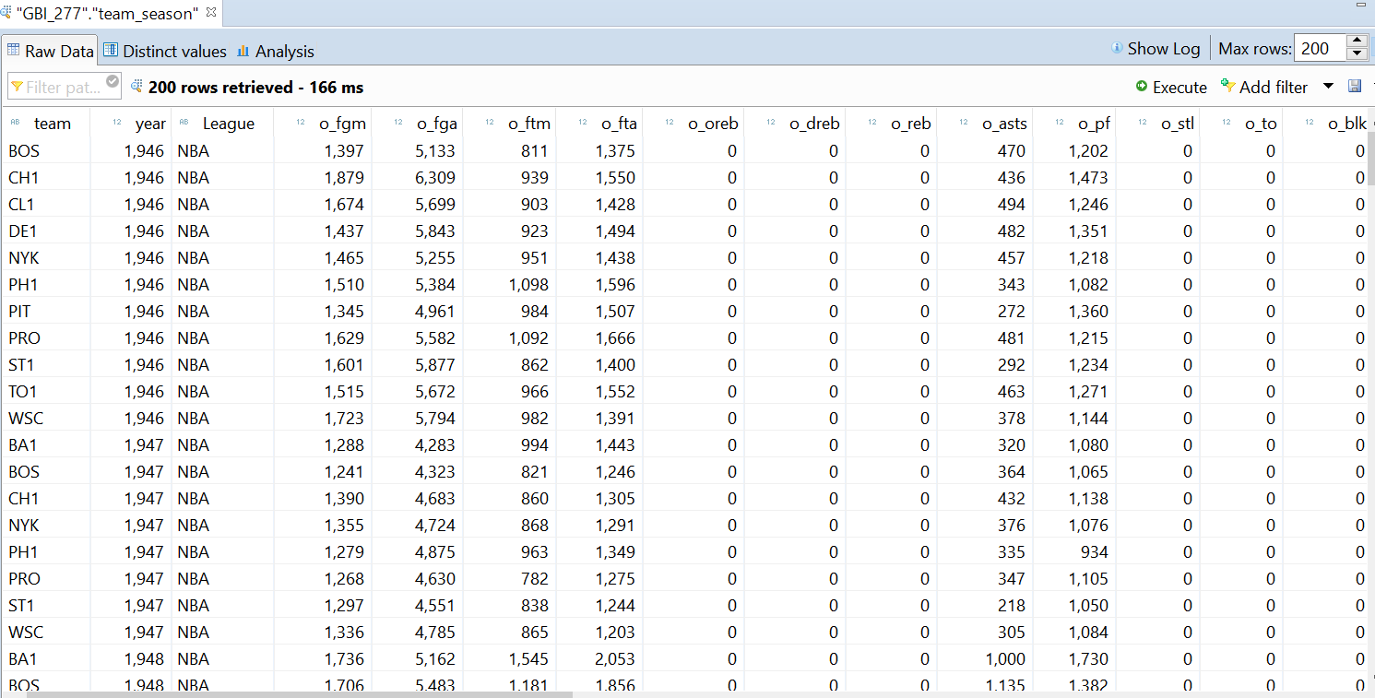

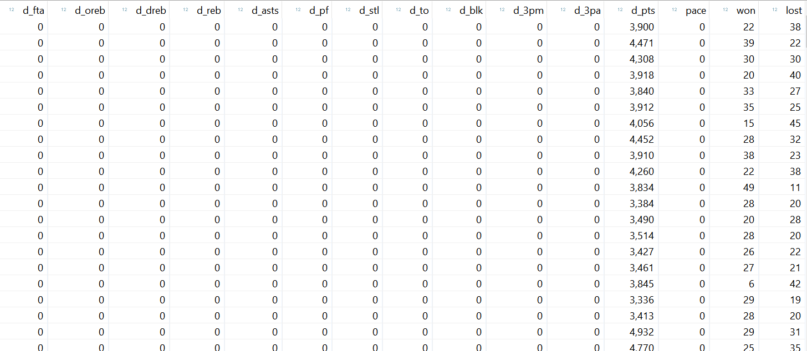

**Table:Coaches_Season**

**Table Definition:**

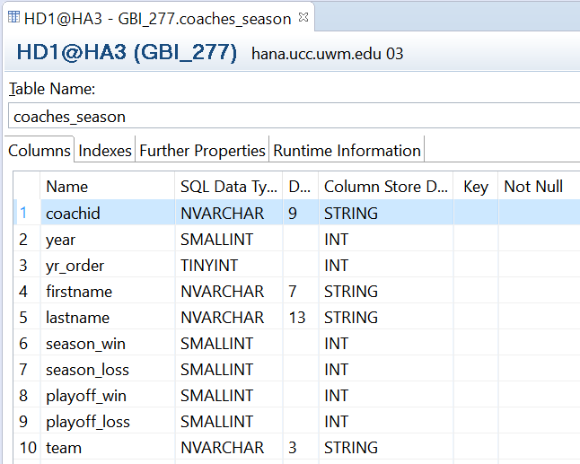

**Imported Table Loaded With Data:**